:param username => 'user_00687';
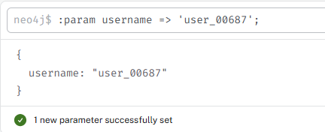
MATCH (u:User {username: $username})-[r]->(target)
RETURN u, r, target
LIMIT 200;
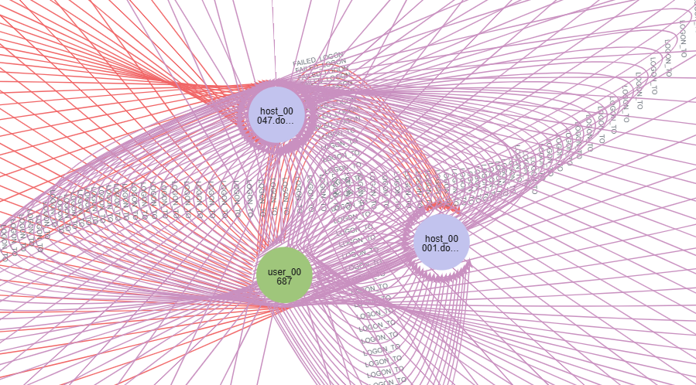is
MATCH (u:User {username: $username})-[r:LOGON_TO]->(dc:DomainController)
OPTIONAL MATCH (u)-[h:ACCESSED_FROM]->(host:Host)
RETURN u, r, dc, h, host
LIMIT 200;
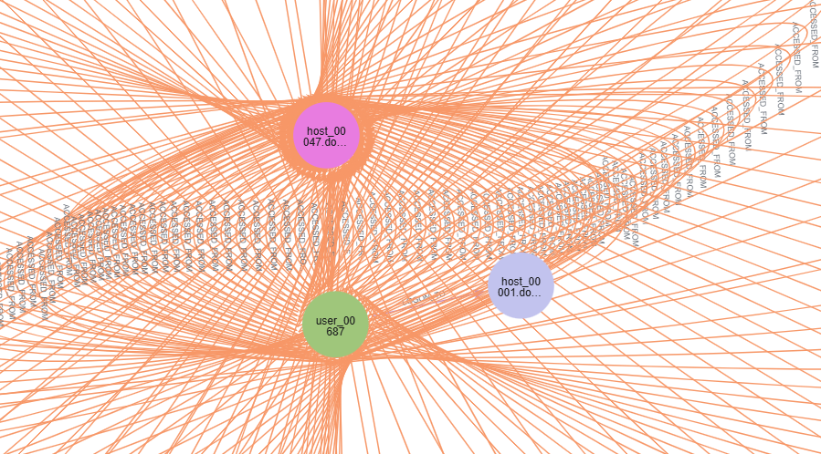

MATCH (u:User {username: $username})-[r:FAILED_LOGON]->(dc:DomainController)
RETURN u, r, dc
LIMIT 200;
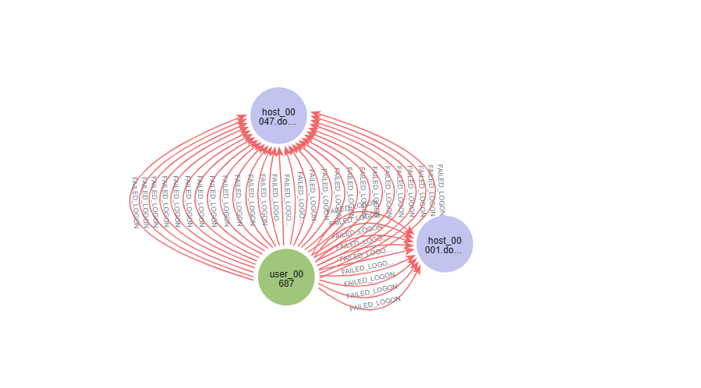

MATCH (u:User {username: $username})-[r:ADDED_TO_GROUP]->(g:Group)
RETURN u, r, g
LIMIT 200;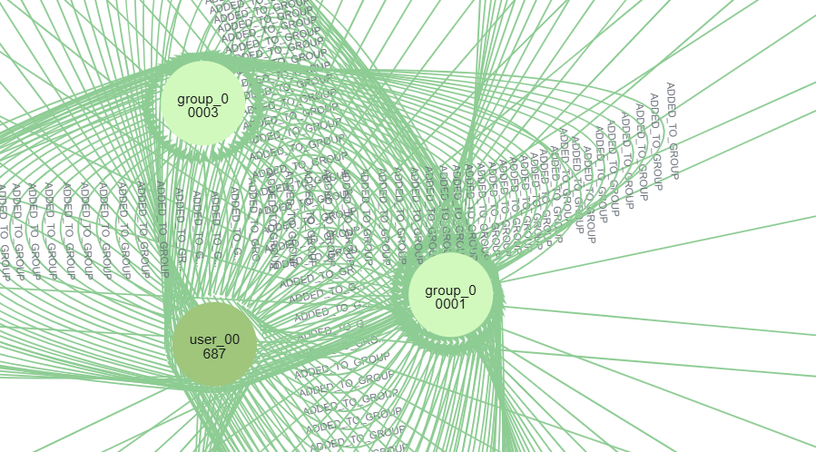

MATCH (u:User {username: $username})-[r:MODIFIED_GPO]->(gpo:GPO)
RETURN u, r, gpo
LIMIT 200;
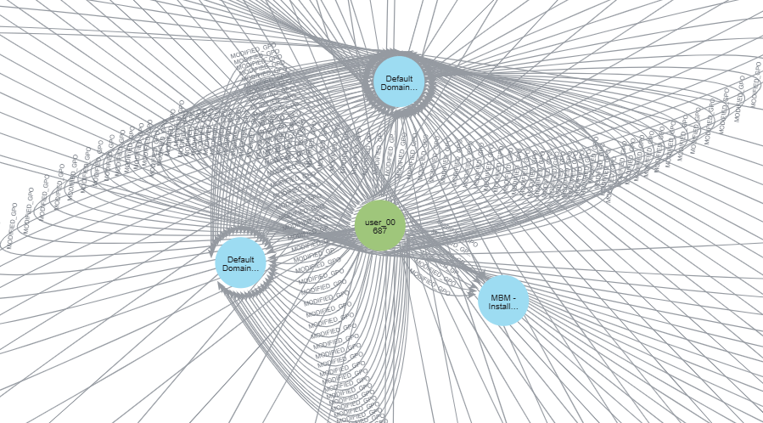
MATCH path=(u:User {username: $username})-[r:LOGON_TO|FAILED_LOGON|ACCESSED_FROM]->(x)
RETURN path
LIMIT 200;


